County Councillor wendy pattison
EGLINGHAM PARISH
COUNTY COUNCILLOR REPORT
wendy.pattison@northumberland.gov.uk – Tel. 07779 983072 Facebook – Cllr Wendy Pattison
EGLINGHAM PARISH

New bus routes unwrapped for 2024
A local bus company is adding a new route to its network, as well as making improvements to current services.
From January 3rd Borders Buses will take over service 418; Wooler to Alnwick via Belford, Bamburgh and Craster. The service is currently operated by bus operator Travelsure; on behalf of Northumberland County Council. The route will be re-launched in the new year with some minor changes.
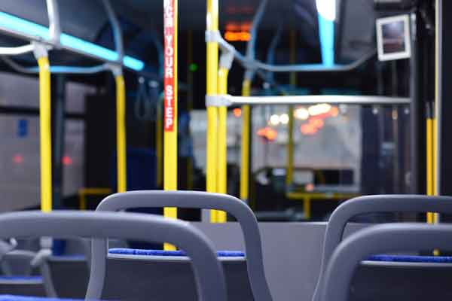
The amends, which are being introduced following customer feedback and consultation with the County Council, include a slight variation to the bus timings and extended journeys between Wooler and Belford.
From this date a simplified timetable will also be launched on service 464; Berwick-Upon-Tweed to Wooler, via Lowick and Scremerston. The updated service will see the removal of the Railway St to Ramparts section of route, customers looking to travel this section of the route can do so on service B1, Berwick Town.
Claire Lark, operations manager at Borders Buses, said: “We are pleased to be working in partnership with Northumberland County Council and delighted to be introducing more journeys for the town, as well as increasing frequency and adding new locations to our bus network. We hope local people make full use and benefit from the new route and extra journeys.
The new route and service improvements are operated on behalf of the County Council.

Help with transport costs
Discounts are available for different types of transport.
Cutting fuel duty - In the Spring Budget 2023 the government extended the fuel duty cut on petrol and diesel of 5 pence per litre for a further 12 months, as well as cancelling the planned inflation increase for 2023-24. Over 2 years this means a saving for drivers worth around £10 billion overall, and for the average car driver around £200, £400 for the average van driver and £3,000 for the average haulier.

Bus travel savings
Single journey ticket (excluding return) discounts include:
- £2 maximum fare cap until December 2024
- https://www.gov.uk/guidance/2-bus-fare-cap#north-east
- £1 bus travel if you are 21 or under
- All day ticket discounts include:
- £5 adult bus travel in Northumberland.
- £6.80 adult travel across Northumberland, Tyne & Wear & County Durham - includes bus, metro or Shields Ferry.
- £3 travel if you are 21 or under across Northumberland, Tyne & Wear & County Durham - includes bus, metro or Shields Ferry.

There are options to claim a bus pass if you are of pension age or have a disability:
- Apply for an older person’s bus pass if you have reached State Pension age. https://northumberland.concessionarytravelpass.co.uk/BusPass/login-or-register?ReturnUrl=%2FBusPas

- Check if you can apply for a disabled person’s bus pass.
https://beta.northumberland.gov.uk/transport/concessionary-travel

Train travel savings
You can save 1/3rd on rail journeys with a rail card:
Find out more about Railcards on the National Rail website.
https://www.nationalrail.co.uk/tickets-railcards-and-offers/railcards/
- Check if you can get a Jobcentre Plus Travel Discount Card on the National Rail website.

Cabinet approve additional support for people with a terminal illness

People with rapidly progressing terminal conditions, can now access non means tested funding up to £6,500 to pay for urgently needed home adaptations.
The scheme approved in Cabinet today, will enable people in the above situations to access a level of Disabled Facilities Grant without the normal requirement to undertake a means test of their ability to contribute to the adaptations.
Northumberland County Councillor Wendy Pattison, Portfolio Holder for Caring for Adults, said: “People who are already dealing with severely disabling degenerative conditions should not have the adaptations they urgently need delayed by red tape.
“This grant would be enough to cover the cost of an adaptation such as a level access shower, a stairlift, or a disabled access ramp, which could make a significant difference to someone’s quality of life and independence.
“People in that situation are already given the highest priority for an assessment by an occupational therapist, but the means test can be an unwelcome source of delay.
“I would encourage anyone in this situation who needs an urgent adaptation to speak to their occupational therapist now.”
The Council already has a policy to provide additional support in special circumstances where the means test for a DFG would otherwise make it difficult or impossible for someone to afford adaptations which they need.
The scheme approved this week extends the circumstances where a discretionary grant can be made.

Community events

Meet and chat with experts about the issues that really matter to you, in your area.

This winter, our Northumberland Communities Together team will be out and about across the county taking part in a range of community events organised by some of our amazing partners.

Please note, not all partners will be in attendance at every event. However, f you have something specific you would like us to discuss and attend in your areas please email NCT@northumberland.gov.uk or call 01670 620015 between 9am to 6pm, seven days a week.

